Batch: C4-1 Roll No.: 16010123217

Experiment / assignment / tutorial No. 2

Grade: AA / AB / BB / BC / CC / CD /DD

Signature of the Staff In-charge with date

TITLE: a. Write a program to accept 3 numbers from the user and find the largest of the
3 numbers using
If - else if-else
Ternary operator
b. Write a C program to find the grade of a student using switch case statements.

AIM: a. Write a program to accept 3 numbers from the user and find the largest of the 3 numbers using
If - else if-else
Ternary operator
b. Write a C program to find the grade of a student using switch case statements.
The below table shows the grading system.

Score in subject | Grade
>=90 | A
80-89 | B
70-79 | C
60-69 | D
50-59 | E
<50 | F

______________________________________________________________________
Expected OUTCOME of Experiment:
Apply basic concepts of C programming for problem solving.(CO1 and CO2).

_____________________________________________________________________
Books/ Journals/ Websites referred:

- Programming in C, second edition, Pradeep Dey and Manas Ghosh, Oxford University Press.
- Programming in ANSI C, fifth edition, E Balagurusamy, Tata McGraw Hill.
- Introduction to programming and problem solving , G. Michael Schneider ,Wiley India edition.
- http://cse.iitkgp.ac.in/~rkumar/pds-vlab/

_____________________________________________________________________
Problem Definition:

- Ask user to input three numbers. Compare three numbers to find the largest of them using
- Nested if else statement
- Using ternary operator
- Write a C program to find the grade of a student using switch case statements.
The below table shows the grading system.

Score in subject | Grade
>=90 | A
80-89 | B
70-79 | C
60-69 | D
50-59 | E
<50 | F

Algorithm:
1) To find largest of three numbers
Step 1 : Start
Step 2 : Input three numbers say num1, num2 and num3
Step 3 : If num1 is greater than or equal to num1 or num2 then
if all are equal then
print All numbers are equal
else if num1 and num2 are equal then
print First and second number are largest which is (num1 or num2)
else if num1 and num3 are equal then
print First and third number are largest which is (num1 or num3)
else
print First number is largest which is (num1).
else if num2 is greater than or equal to num1 or num3 then
if num1 and num2 are equal then
print First and second number are largest which is (num1 or num2)
else if num2 and num3 are equal then
print Second and third number are largest which is (num2 or num3)
else
print Second number is largest which is (num2).
else
print Third number is largest which is (num3).
Step 4 : Stop
2) Algorithm for Grade Calculator
Step 1 : Start
Step 2 : Input marks out of 100
Step 3 : If marks are within range (0,101) then
Dividing marks by 10 to get a single-digit number for grade determination
Using switch statement to determine the grade
Cases 10 and 9: Assign grade A.
Case 8: Assign grade B.
Case 7: Assign grade C.
Case 6: Assign grade D.
Case 5: Assign grade E.
Default (marks below 5): Assign grade F.

Print the assigned grade using printf

Else
Print an error message using printf asking for correct marks
Step 4 : Stop

Implementation Details:
1) Code: Using Nested if else
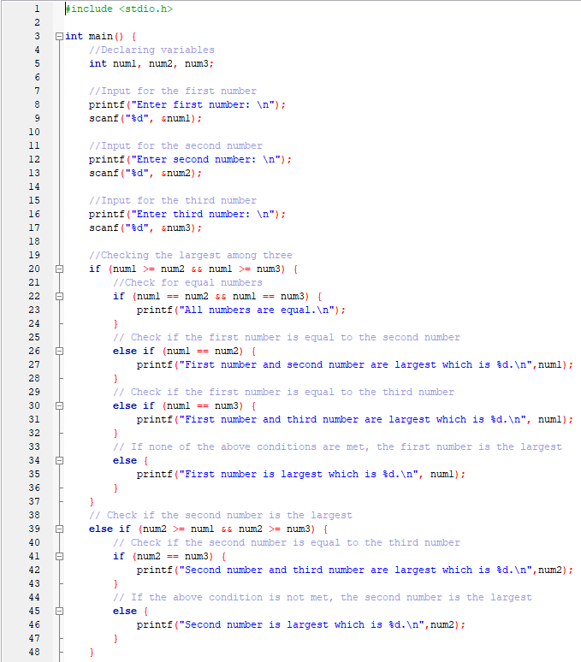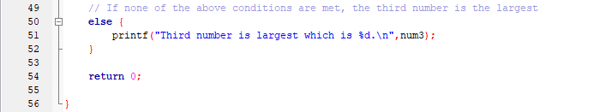

Using Ternary Operator
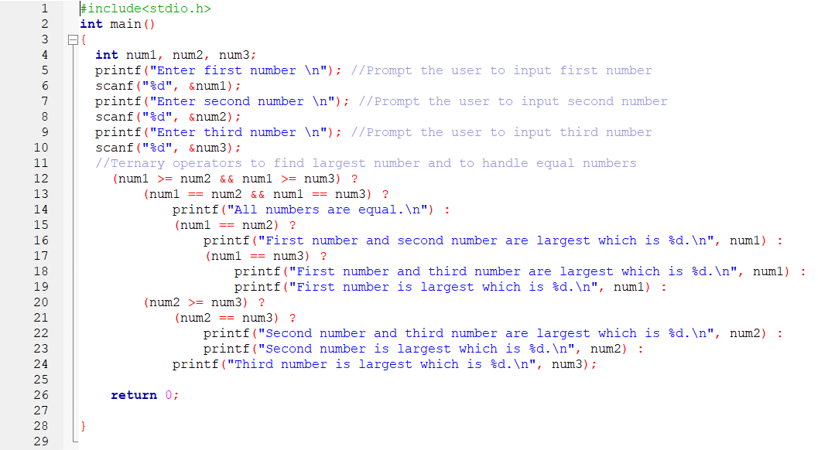

2) Code : Grade Calculator
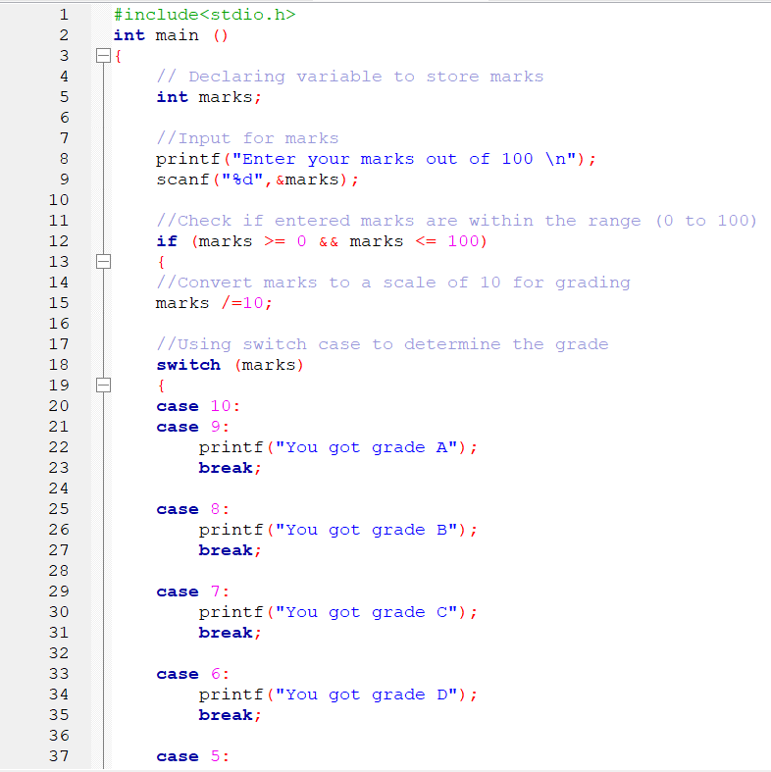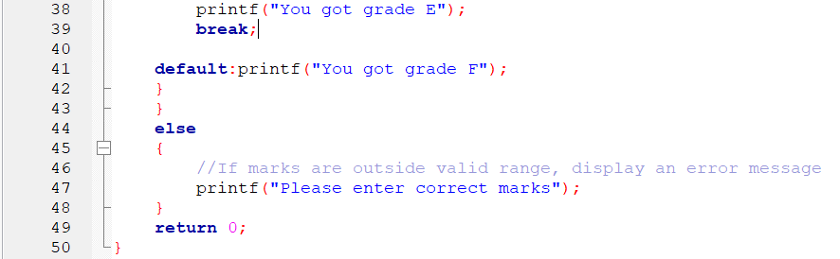

Output(s):
1) Using Nested if-else
Test Case 1 : All numbers are distinct
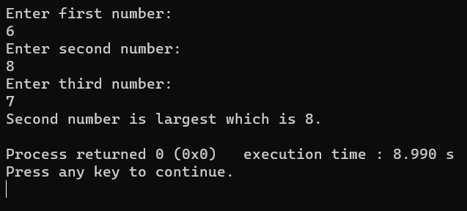
Test Case 2 : Two numbers are distinct
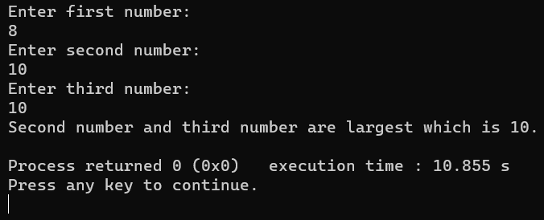
Test Case 3 : All numbers are equal
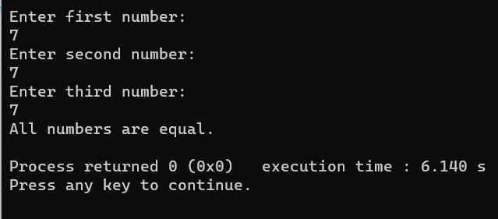
Using Ternary operator
Test Case 1 : All numbers are distinct
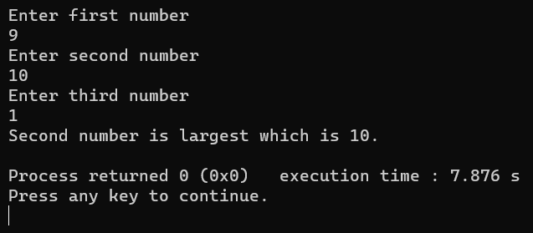
Test Case 2 : Two numbers are distinct
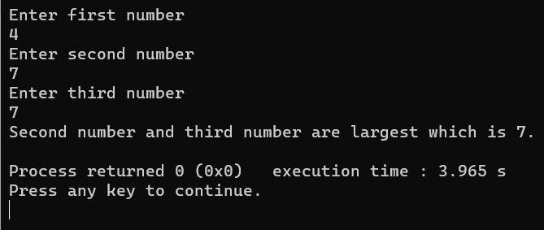
Test Case 3 : All numbers are equal
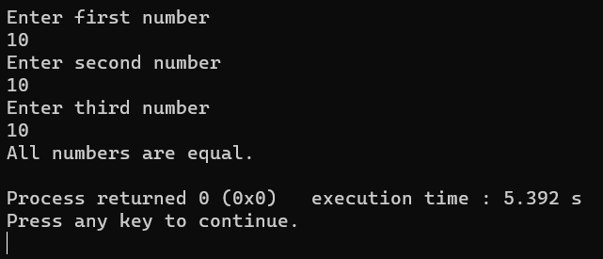
2) Test 1 : If user inputs proper marks between (0-100)ae
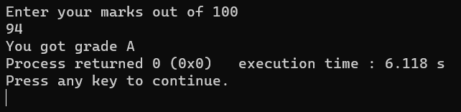
Test 2 : If user inputs marks out of range (0-100)
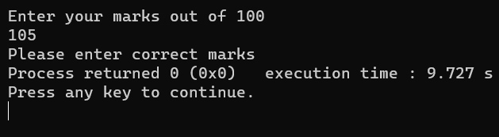
Conclusion:
In this experiment we learned to make use of nested if- else statements, ternary operator and switch-case statements. By performing the experiment we found out that there are better ways to write the same code as using ternary operators reduced the execution time as compared to nested if-else statements for the same problem statement.
Also switch case statement allows the best-optimized implementation for faster code execution than the “if-else if” statement.

Post Lab Descriptive Questions
- Virtual lab for switch statement
https://cse02-iiith.vlabs.ac.in/exp/basic-control-flow/simulation.html

- Virtual lab for if statement
https://cse02-iiith.vlabs.ac.in/exp/basic-control-flow/simulation.html

Date: _____________ Signature of faculty in-charge

